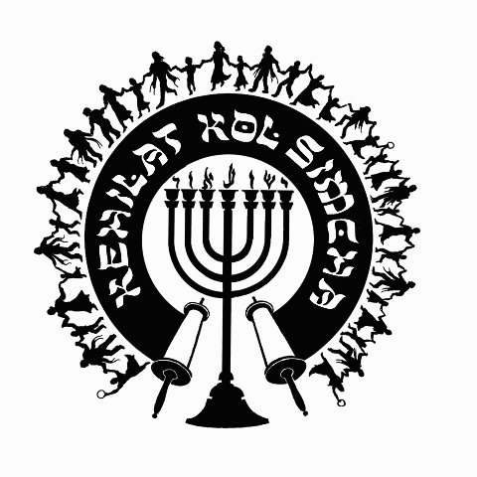
Kol Simcha
Messianic Congregation
5020 NW 23rd Ave.
Gainesville, FL 32606
(352) 372-4574 Ext. 2
{P.O. Box 358924
Gainesville, FL 32635-8924}
“Kol Sason V’Kol Simcha, Kol Chatan V’Kol Kala”
“The voice of joy, and the voice of gladness, the voice of the bridegroom, and the voice of the bride…” (Jer. 33:11)
A family-oriented congregation of Jewish and Gentile believers who worship Israel’s Messiah, Y’shua HaMashiac (Jesus Christ), in the context of Jewish lifestyle and identity. We are committed to restoring the family unit and the Biblical/Jewish roots of our faith in the God of Abraham, Isaac and Jacob. Come share the joy!

December 20, 2017

5778-5779 High Holiday Services Schedule
(All Times are Tentative at Best… See Website for last minute changes)

Chanukah
First Night Sunday Night December 12, 2017 at sundown
Eight Night Sunday Night December 19, 2017 at sundown

Purim
Purim Wednesday Evening Feb. 28, 2018 at ~7:00pm (sundown 6:28pm)

Pesach / Feast of Matzot (Passover, Lev. 23:4-14)
14th Aviv Thursday Evening March 29, 2018 at 7:30pm (sundown, Kol Simcha’s Yeshua Passover Seder)
15th Aviv Eve Friday Night March 30, 2018 (1st Seder, Feast of Unleavened Bread, No service, Seder at home)
15th Aviv Day Saturday March 31, 2018 15th Aviv First Day of Unleavened Bread at Noon (Tentative No Oneg)
21st Aviv Eve Thursday April 5, 2018 7:30p (Worship-Only)
21st Aviv Day Friday April 6, 2018 11a (Tentative No Oneg)

Shavuot (Pentecost, Lev. 23:15-22)
Saturday Night May 19, 2018 at 6:30pm
Kol Simcha Shavuot Picnic Sunday May 20, 2018 9am at Poe Springs

Rosh Hashanah (Feast of Trumpets, Yom Teruah, Lev. 23:24)
Sunday Evening September 9, 2018 at 7:42pm (sundown)
Monday Morning September 10, 2018 at Noon (Full Oneg)

Yom Kippur ( Day of Atonement, Lev. 23:27)
Tuesday Evening September 18, 2018 at 7:31pm (sundown)
Wednesday Morning September 19, 2018 at 12pm (Noon, followed by “break fast” at sundown)

Sukkot (Feast of Tabernacles, Lev. 23:34)
1st Day
Sunday Evening September 23, 2018 at 7:30pm (Worship Only Service)
Monday Morning September 24, 2018 at Noon (Full Oneg)

8th Day - Shemini Atzeret / Simchat Torah
Sunday Evening September 30, 2018 at 7:30pm (Worship Only Service)
Monday Morning October 1, 2018 at 11am (Full Oneg)

Chanukah
First Night Sunday Night December 2, 2018 at sundown
Eight Night Sunday Night December 9, 2018 at sundown

Rabbi A. Antonio Arroyo

