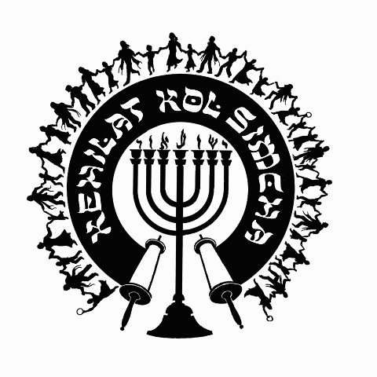
Kehilat
Kol Simcha
2925 NW 39th Ave.
Gainesville, FL 32605
(352) 485-1210
{P.O. Box 358924
Gainesville, FL 32635-8924}
“Kol Sason V’Kol Simcha, Kol Chatan V’Kol Kala”
“The voice of joy, and the voice of gladness, the voice of the bridegroom, and the voice of the bride…” (Jer. 33:11)
A family-oriented congregation of Jewish and Gentile believers who worship Israel’s Messiah, Y’shua HaMashiac (Jesus Christ), in the context of Jewish lifestyle and identity. We are committed to restoring the family unit and the Biblical/Jewish roots of our faith in the God of Abraham, Isaac and Jacob. Come share the joy!

October 29, 2019

5780-5781 (2020) High Holiday Services Schedule
(All Times are Tentative at Best… See Website for last minute changes)

Chanukah
- First Night Sunday Night December 22, 2019 at sundown, No Service
- Eight Night Sunday Night December 29, 2019 at at 6pm, KS Chanukah Party in the Kids Building

Purim
Purim Monday Evening Mar. 9, 2020 at ~7:30pm (sundown 7:34pm) Main Sanctuary

Pesach / Feast of Matzot (Passover, Lev. 23:4-14)
14th Aviv Tue. Evening April 7, 2020 at 7:30pm (sundown 7:51p, Kol Simcha’s Yeshua Passover Seder) Main Sanctuary
15th Aviv Eve Wednesday Night April 8, 2020 (1st Seder, Feast of Unleavened Bread, No service, Seder at home)
15th Aviv Day Thu. April 9, 2020 15th Aviv First Day of Unleavened Bread at 12pm (Coffee & Snacks) Main Sanctuary
21st Aviv Eve Tuesday April 14, 2020 7:30p (Worship-Only) Main Sanctuary
21st Aviv Day Wednesday April 15, 2020 10a (Coffee & Snacks) Main Sanctuary

Shavuot (Pentecost, Lev. 23:15-22)
Saturday Night May 30, 2020 at 6:30pm Main Sanctuary
Kol Simcha Shavuot Picnic Sunday May 31, 2020 @ 9am at Poe Springs

Rosh Hashanah (Feast of Trumpets, Yom Teruah, Lev. 23:24)
Friday Evening September 18, 2020 at 7:30pm (sundown) Main Sanctuary
Saturday Morning September 19, 2020 at 10am (No Oneg) Main Sanctuary

Yom Kippur ( Day of Atonement, Lev. 23:27)
Sunday Evening September 27, 2020 at 7:15pm (7:17pm sundown) Main Sanctuary
Monday Morning September 28, 2020 at 12pm (Noon, followed by “break fast” at sundown) Main Sanctuary

Sukkot (Feast of Tabernacles, Lev. 23:34)
1st Day
Friday Evening October 2, 2020 at 7:30pm (in the Sukkah Service) Pavilion
Saturday Morning October 3, 2020 at 10am (Full Oneg in Sukkah) Main Sanctuary

8th Day - Shemini Atzeret / Simchat Torah
Friday Evening October 9, 2020 at 7:30pm (in the Sukkah Service) Pavilion
Saturday Morning October 10, 2020 at 10am (Full Oneg) Main Sanctuary

Chanukah
First Night Thursday Night December 10, 2020 at sundown, No Service
Eight Night Thursday Night December 17, 2020 at at 6pm, KS Chanukah Party in the Kids Building

Rabbi A. Antonio Arroyo

