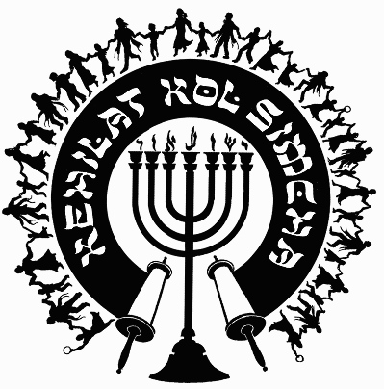
Kehilat
Kol Simcha
2925 NW 39th Ave.
Gainesville, FL 32605
(352) 485-1210
{P.O. Box 358924
Gainesville, FL 32635-8924}
“Kol Sason V’Kol Simcha, Kol Chatan V’Kol Kala”
“The voice of joy, and the voice of gladness, the voice of the bridegroom, and the voice of the bride…” (Jer. 33:11)
A family-oriented congregation of Jewish and Gentile believers who worship Israel’s Messiah, Y’shua HaMashiac (Jesus Christ), in the context of Jewish lifestyle and identity. We are committed to restoring the family unit and the Biblical/Jewish roots of our faith in the God of Abraham, Isaac and Jacob. Come share the joy!

November 6, 2020

5781-5782 (2021) High Holiday Services Schedule
(All Times are Tentative at Best… See Website for last minute changes)

Chanukah
First Night Thursday Night December 10, 2020 at sundown, No Service
Eight Night Thursday Night December 17, 2020 at at 6pm, KS Chanukah Party in the Kids Building

Purim
Purim Thursday Evening Feb. 25, 2021 at ~6:30pm (sundown 6:25pm) Main Sanctuary

Pesach / Feast of Matzot (Passover, Lev. 23:4-14)
14th Aviv Fri. Evening March 26, 2021 at 7:30pm (sundown 7:44p, Kol Simcha’s Yeshua Passover Seder) Main Sanctuary
15th Aviv Eve Saturday Night March 27, 2021 (1st Seder, Feast of Unleavened Bread, No service, Seder at home)
15th Aviv Day Sun. March 28, 2021 15th Aviv First Day of Unleavened Bread (Coffee & Snacks) at GHC, TBA
21st Aviv Eve Friday April 2, 2021 7:30p (Worship-Only) Main Sanctuary
21st Aviv Day Saturday April 3, 2021 10a (Coffee & Snacks) Main Sanctuary

Shavuot (Pentecost, Lev. 23:15-22)
Saturday Night May 22, 2021 at 6:30pm Main Sanctuary
Kol Simcha Shavuot Picnic Sunday May 23, 2021 @ 9am at Poe Springs

Rosh Hashanah (Feast of Trumpets, Yom Teruah, Lev. 23:24)
Monday Evening September 6, 2021 at 7:30pm (sundown 7:44pm) Main Sanctuary
Tuesday Morning September 7, 2021 at 10am (No Oneg) Main Sanctuary

Yom Kippur ( Day of Atonement, Lev. 23:27)
Wednesday Evening September 15, 2021 at 7:30pm (7:33pm sundown) Main Sanctuary
Thursday Morning September 16, 2021 at 12pm (Noon, followed by “break fast” at sundown) Main Sanctuary

Sukkot (Feast of Tabernacles, Lev. 23:34)
1st Day
Monday Evening September 20, 2021 at 7:30pm (in the Sukkah Service) Pavilion
Tuesday Morning September 21, 2021 at 10am (Full Oneg in Sukkah) Main Sanctuary

8th Day - Shemini Atzeret / Simchat Torah
Monday Evening September 27, 2021 at 7:30pm (in the Sukkah Service) Pavilion
Tuesday Morning September 28, 2021 at 10am (Full Oneg) Main Sanctuary

Chanukah
First Night Sunday Night November 28, 2021 at sundown, No Service
Eight Night Sunday Night December 5, 2021 at at 5:30pm, KS Chanukah Party in the Kids Building

Rabbi A. Antonio Arroyo

