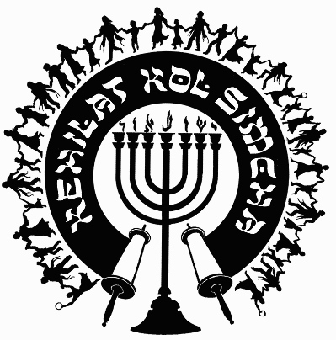
Kehilat
Kol Simcha
2925 NW 39th Ave.
Gainesville, FL 32605
(352) 485-1210
{P.O. Box 358924
Gainesville, FL 32635-8924}
“Kol Sason V’Kol Simcha, Kol Chatan V’Kol Kala”
“The voice of joy, and the voice of gladness, the voice of the bridegroom, and the voice of the bride…” (Jer. 33:11)
A family-oriented congregation of Jewish and Gentile believers who worship Israel’s Messiah, Y’shua HaMashiac (Jesus Christ), in the context of Jewish lifestyle and identity. We are committed to restoring the family unit and the Biblical/Jewish roots of our faith in the God of Abraham, Isaac and Jacob. Come share the joy!

September 23, 2022

5782-5783 (2022) High Holiday Services Schedule
(All Times are Tentative at Best… See Website for last minute changes)

Purim
Purim Katan Monday Evening Feb. 14, 2022 No Service
Purim Wednesday March 16, 2022 at ~6:30pm (sundown 7:39pm) Main Sanctuary

Pesach / Feast of Matzot (Passover, Lev. 23:4-14)
14th Aviv Thu. Evening April 14, 2022 at 7:30pm (sundown 7:56p, Kol Simcha’s Yeshua Passover Seder) Gymnasium or TBD
15th Aviv Eve Friday Night April 15, 2022 (1st Seder, Feast of Unleavened Bread, No service, Seder at home)
15th Aviv Day Sat. April 16, 2022 15th Aviv First Day of Unleavened Bread Main Sanctuary
21st Aviv Eve Thursday April 21, 2022 7:30p (Worship-Only) Main Sanctuary – Tentative
21st Aviv Day Friday April 22, 2022 10a Main Sanctuary

Shavuot (Pentecost, Lev. 23:15-22)
Kol Simcha Shavuot Service & Picnic Sunday June 5, 2022 @ 9am at Poe Springs

Rosh Hashanah (Feast of Trumpets, Yom Teruah, Lev. 23:24)
Sunday Evening September 25, 2022 at 7:30pm (sundown 7:21pm, Sweets Oneg) Main Sanctuary
Monday Morning September 26, 2022 at 10am (Full Oneg) Main Sanctuary

Yom Kippur ( Day of Atonement, Lev. 23:27)
Tuesday Evening October 4, 2022 at 7:30pm (7:11pm sundown) Main Sanctuary
Wednesday Morning October 5, 2022 at 12pm (Noon, NO “break fast” at sundown) Main Sanctuary

Sukkot (Feast of Tabernacles, Lev. 23:34)
1st Day
Sunday Evening October 9, 2022 at 7:00pm (in the Sukkah Service) Pavilion
Monday Morning October 10, 2022 at 10am (Full Oneg in Sukkah) Main Sanctuary

8th Day - Shemini Atzeret / Simchat Torah
No service Sunday Evening October 16, 2022
Monday Morning October 17, 2022 at 10am (Full Oneg) Main Sanctuary

Chanukah
First Night Sunday Night December 18, 2022 at sundown, No Service
Eight Night Sunday Night December 25, 2022 at at 5:30pm, KS Chanukah Party in the Kids Building

Rabbi A. Antonio Arroyo

