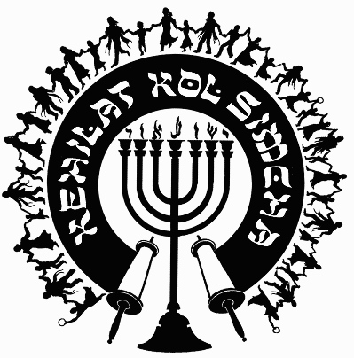
Kehilat
Kol Simcha
2925 NW 39th Ave.
Gainesville, FL 32605
(352) 485-1210
{P.O. Box 358924
Gainesville, FL 32635-8924}
“Kol Sason V’Kol Simcha, Kol Chatan V’Kol Kala”
“The voice of joy, and the voice of gladness, the voice of the bridegroom, and the voice of the bride…” (Jer. 33:11)
A family-oriented congregation of Jewish and Gentile believers who worship Israel’s Messiah, Y’shua HaMashiac (Jesus Christ), in the context of Jewish lifestyle and identity. We are committed to restoring the family unit and the Biblical/Jewish roots of our faith in the God of Abraham, Isaac and Jacob. Come share the joy!

February 23, 2023

5784-5785 (2024) High Holiday Services Schedule
(All Times are Tentative at Best… See Website for last minute changes)

Purim
Erev Purim Saturday March 23, 2024, at ~6:30pm (after sunset) Main Sanctuary

Pesach / Feast of Matzot (Passover, Lev. 23:4-14)
14th Aviv Sun. Evening April 21, 2024, at 7:00pm (sunset 7, Kol Simcha’s Yeshua Passover Seder) Gymnasium
15th Aviv Eve Mon. Night April 22, 2024, (1st Seder, Feast of Unleavened Bread, No service, Seder at home)
15th Aviv Day Tu. April 23, 2024, 15th Aviv First Day of Unleavened Bread 10a Main Sanctuary
21st Aviv Eve Sunday April 28, 2024, Main Sanctuary – (sundown) TBA
21st Aviv Day Mon. April 29, 2024, 10a Main Sanctuary

Shavuot (Pentecost, Lev. 23:15-22)
Kol Simcha Shavuot Service & Picnic Sunday June 16, 2024 @ 9am at Poe Springs

Rosh Hashanah (Feast of Trumpets, Yom Teruah, Lev. 23:24)
Wednesday Evening October 2, 2024, at 7:30pm (after sunset, Sweets Oneg) Main Sanctuary
Thursday Morning October 3, 2024, at 10am (Full Oneg) Main Sanctuary

Yom Kippur ( Day of Atonement, Lev. 23:27)
Friday Evening October 11, 2024, at 7:00pm (after sunset) Main Sanctuary
Saturday Morning October 12, 2024, at 12pm (Noon, “break-fast” TBA at sunset) Main Sanctuary

Sukkot (Feast of Tabernacles, Lev. 23:34)
1st Day
Wednesday Evening October 16, 2024, at 7:30pm (in the Sukkah Service) Pavilion
Thursday Morning October 17, 2024, at 10am (Full Oneg in Sukkah) Main Sanctuary

8th Day - Shemini Atzeret / Simchat Torah
Wednesday Evening October 23, 2024, service TBA
Thursday Morning October 24, 2024, at 10am (Full Oneg) Main Sanctuary

Chanukah
First Night Wednesday Night December 25, 2024, at sunset, No Service
Eight Night Wednesday Night January 1, 2025, at 5:30pm, KS Chanukah Party in the Kids Building

Rabbi A. Antonio Arroyo

