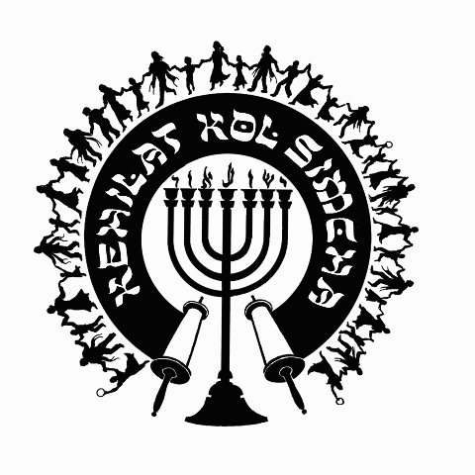
Kol Simcha
Messianic Congregation
619 NE First Street
(352) 485-1210
{P.O. Box 12749
Gainesville, FL 32604-0749}
“Kol Sason V’Kol Simcha, Kol Chatan V’Kol Kala”
“The voice of joy, and the voice of gladness, the voice of the bridegroom, and the voice of the bride…” (Jer. 33:11)
A family-oriented congregation of Jewish and Gentile believers who worship Israel’s Messiah, Y’shua HaMashiac (Jesus Christ), in the context of Jewish lifestyle and identity. We are committed to restoring the family unit and the Biblical/Jewish roots of our faith in the God of Abraham, Isaac and Jacob. Come share the joy!

April 2, 2017

5777-5778 High Holiday Services Schedule
(All Times are Tentative at Best… See Website for last minute changes)

Chanukah
First Night Sunday Night December 24, 2016 at sundown
Eight Night Sunday Night December 31, 2016 at sundown

Purim
Purim Saturday Evening Mar. 11, 2017 at ~7:00pm (sundown 6:36pm)

Pesach / Feast of Matzot (Passover, Lev. 23:4-14)
14th Aviv Sunday Evening April 9, 2017 at 7:30pm (sundown, Kol Simcha’s Yeshua Passover Seder)
15th Aviv Eve Monday Night April 10, 2017 (1st Seder, Feast of Unleavened Bread, No service, Seder at home)
15th Aviv Day Tuesday April 11, 2017 15th Aviv First Day of Unleavened Bread at Noon (Tentative No Oneg)
21st Aviv Day Monday April 17, 2017 11a (Tentative No Oneg)

Shavuot (Pentecost, Lev. 23:15-22)
Saturday Night June 3, 2017 at 6:30pm
Kol Simcha Shavuot Picnic Sunday June 4, 2017 9am at Poe Springs

Rosh Hashanah (Feast of Trumpets, Yom Teruah, Lev. 23:24)
Wednesday Evening September 20, 2017 at 7:29pm (sundown)
Thursday Morning September 21, 2017 at 11am (Full Oneg)

Yom Kippur ( Day of Atonement, Lev. 23:27)
Friday Evening September 29, 2017 at 7:18pm (sundown)
Saturday Morning September 30, 2017 at 12pm (Noon, followed by “break fast” at sundown)

Sukkot (Feast of Tabernacles, Lev. 23:34)
1st Day
Wednesday Evening October 4, 2017 at 7:00pm (Worship Only Service)
Thursday Morning October 5, 2017 at 11am (Full Oneg)

8th Day - Shemini Atzeret / Simchat Torah
Wednesday Evening October 11, 2017 at 7:00pm (Worship Only Service)
Thursday Morning October 12, 2017 at 10am (Full Oneg)

Chanukah
First Night Sunday Night December 12, 2017 at sundown
Eight Night Sunday Night December 19, 2017 at sundown

Rabbi A. Antonio Arroyo

