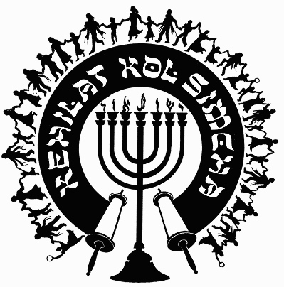
Kehilat
Kol Simcha
2925 NW 39th Ave.
Gainesville, FL 32605
(352) 485-1210
{P.O. Box 358924
Gainesville, FL 32635-8924}
“Kol Sason V’Kol Simcha, Kol Chatan V’Kol Kala”
“The voice of joy, and the voice of gladness, the voice of the bridegroom, and the voice of the bride…” (Jer. 33:11)
A family-oriented congregation of Jewish and Gentile believers who worship Israel’s Messiah, Y’shua HaMashiac (Jesus Christ), in the context of Jewish lifestyle and identity. We are committed to restoring the family unit and the Biblical/Jewish roots of our faith in the God of Abraham, Isaac and Jacob. Come share the joy!

October 24, 2022

5783-5784 (2023) High Holiday Services Schedule
(All Times are Tentative at Best… See Website for last minute changes)

Purim
Erev Purim Tuesday March 7, 2023, at ~6:30pm (sunset 6:32pm) Main Sanctuary

Pesach / Feast of Matzot (Passover, Lev. 23:4-14)
14th Aviv Tue. Evening April 4, 2023, at 6:30pm (sunset 7:49p, Kol Simcha’s Yeshua Passover Seder) Gymnasium
15th Aviv Eve Wed. Night April 5, 2023, (1st Seder, Feast of Unleavened Bread, No service, Home Seder)
15th Aviv Day Thu. April 6, 2023, 15th Aviv First Day of Unleavened Bread 10a Main Sanctuary
21st Aviv Eve Tuesday April 11, 2023, sundown, No service
21st Aviv Day Wed. April 12, 2023, 10a Main Sanctuary

Shavuot (Pentecost, Lev. 23:15-22)
Kol Simcha Shavuot Service & Picnic Sunday May 28, 2023 @ 9am at Poe Springs

Rosh Hashanah (Feast of Trumpets, Yom Teruah, Lev. 23:24)
Friday Evening September 15, 2023, at 7:30pm (sunset 7:34pm, Sweets Oneg) Main Sanctuary
Saturday Morning September 16, 2023, at 10am (Full Oneg) Main Sanctuary

Yom Kippur ( Day of Atonement, Lev. 23:27)
Sunday Evening September 24, 2023, at 7:00pm (7:23pm sunset) Main Sanctuary
Monday Morning September 25, 2023, at 12pm (Noon, NO “break fast” at sunset) Main Sanctuary

Sukkot (Feast of Tabernacles, Lev. 23:34)
1st Day
Sunday Evening September 29, 2023, at 7:30pm (in the Sukkah Service) Pavilion
Saturday Morning September 30, 2023, at 10am (Full Oneg in Sukkah) Main Sanctuary

8th Day - Shemini Atzeret / Simchat Torah
Friday Evening October 6, 2023, TBA
Saturday Morning October 7, 2023, at 10am (Full Oneg) Main Sanctuary

Chanukah
First Night Thursday Night December 7, 2023, at sunset, No Service
Eight Night Thursday Night December 14, 2023, at 5:31pm, KS Chanukah Party in the Kids Building

Rabbi A. Antonio Arroyo

